|  |  |  |  |  |
| --- | --- | --- | --- | --- |
| Subject | : Stabilization Activities |  | Date | : 22nd August 2011 |
| Machine | : Taping OAI |  | Prepared | : Zulhisham Tan |
| Section | : PX Line |  | Status | : Machine Running With Condition |

I have put some effort to study the setting of the Vision system in order to maintain the machine performance. After a magnet bar is installed, a standard image which looks similar to the figure below can be easily achieved. In this paper, we recommended that the gain of the camera as well as the filtering setting is adjusted so that the image is similar to the one shown below. In which there are no distortion surrounding the marking characters.

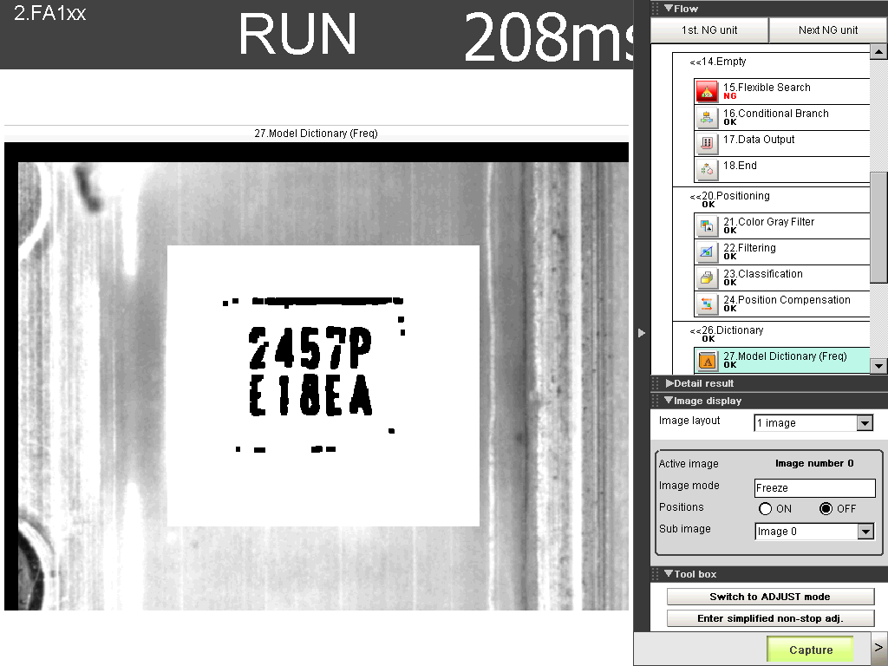

Increasing the Gain in ‘Camera Input Image’ will increase the contrast of the image. Hence, it will reduce the ‘Black Dot’ surrounding the marking character. The ‘Black Dot’ is eventually a shadow cause by the rough surface of the Lead. In the case of the Lead is dented, the image will turns dark, the system will still be able to identify since most of the marking character is unable to recognize.

There is no significant effect to the measurement time when the gain is adjusted. This is because the gain of the camera will only affected the contrast of the image. In fact, no any measurement processes is carried out at this time.

However, image capture speed will be affected by the shuttle speed. The shuttle speed represents how soon the shuttle will be closed after it has been trigger to open. The brightness of the image will has significant effect by adjust the shuttle speed. Anyway, the shuttle speed of the Taping OAI machine is 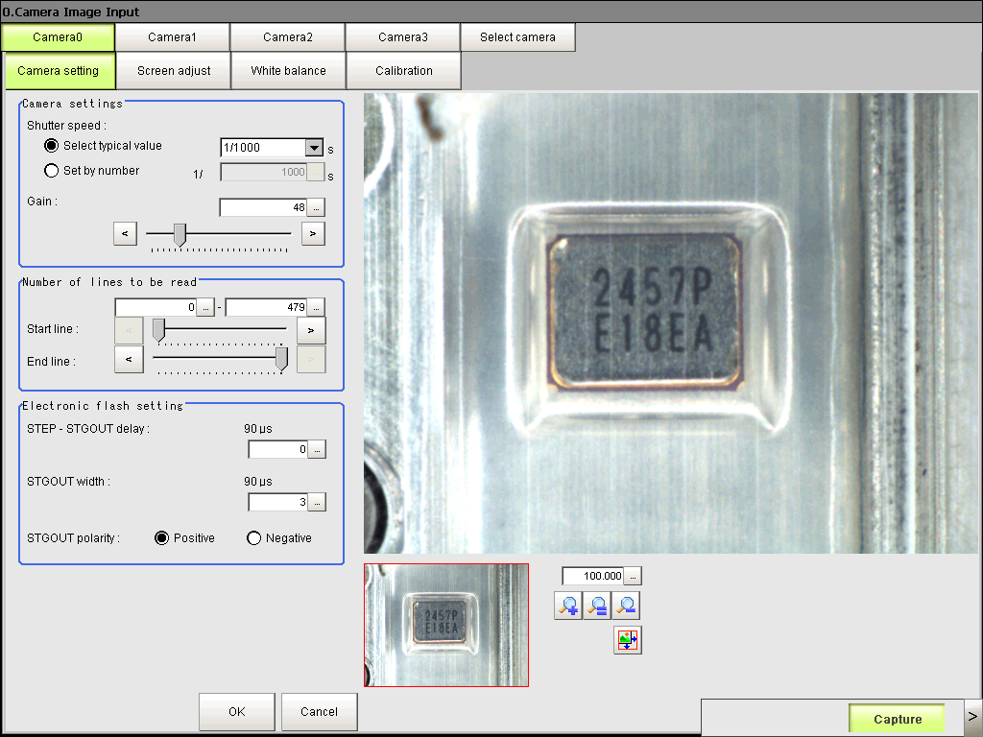maintain at 1/1000 in order to avoid any conflict of understanding.

At the time of writing this paper, the Gain for FA-20H and FA-128 product is in the range of 40 to 60. However, it depends on the lighting condition.

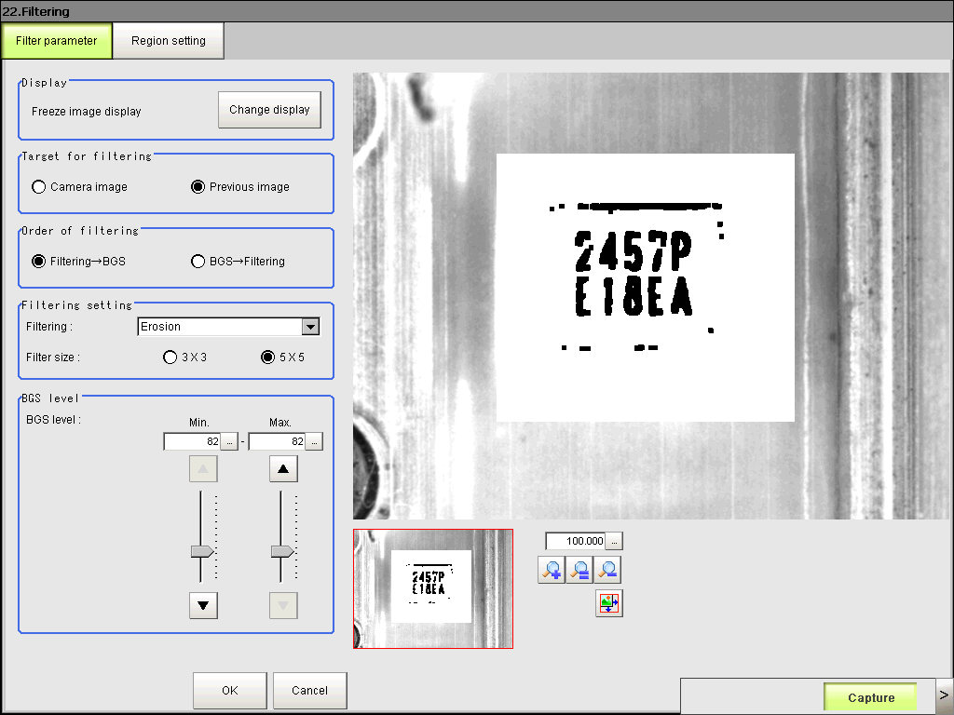 Another concern of getting the standard image as mentioned earlier, the BGS setting of the filtering play significant important rules here. By choosing Erosion (convert gray dot to black dot) will makes the line of a character look thinker. Choose the filtering size 5x5 will make the marking character even clearer. The BGS level is adjust so that no distortion can be seen.

How well the measurement is done is depends on the quality of the input image. The better the image, the shorter time the Vision system will take to measure.

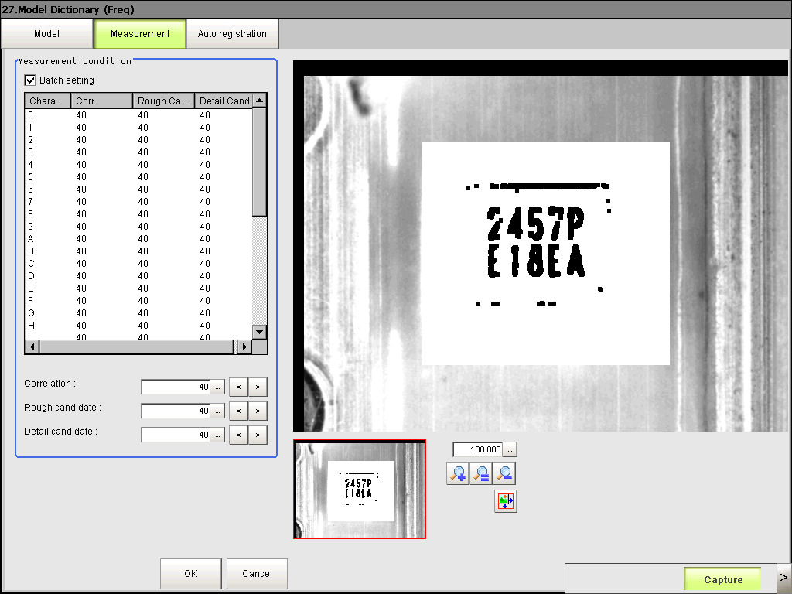

In fact, how accurate is the Vision system would recognize a character is also depends on the quality of the input image. In the case of our Taping OAI, marking quality is different from 1 Laser Marking machine to another. As such the probability in getting a perfect image is almost impossible. Without a sharp image, character recognition is significantly a difficult task.

To address this issue, we strongly recommended the setting of the Camera’s gain as well as the filtering technique we have discussed earlier. As we also know, the quality of the marking are vary from one marking machine to the others, due to the reason we have another issue of teaching the Vision system to recognize a character. It is difficult to maintain a dictionary of master character based on the individual Laser Marking machine.

In order to make the Vision system’s task simpler, the setting of ‘Correlation’, ‘Rough Candidate’, ‘Detail Candidate’ is make as low as possible so that the Vision system will simply return a character it has been recognized. This is done because a De Factor standard has been setup to handle incorrect data from the Vision system. Setting these value to below 45 will have significant effect to measurement cycle time. However, it can be reduce and fine tune with another option – that’s the Region of Interest is the ‘Character Inspection’.

In the case of the case study below, the image is interrupted by a tiny line at the Top-Tape, parts of the information from the image is lost. In order to recover the data, we propose the use of De Facto standard, where the vision system will make to simply return a closest character that it recognized. It will then re-calculate based on the characteristics of the marking data to recover the lost information from the image.

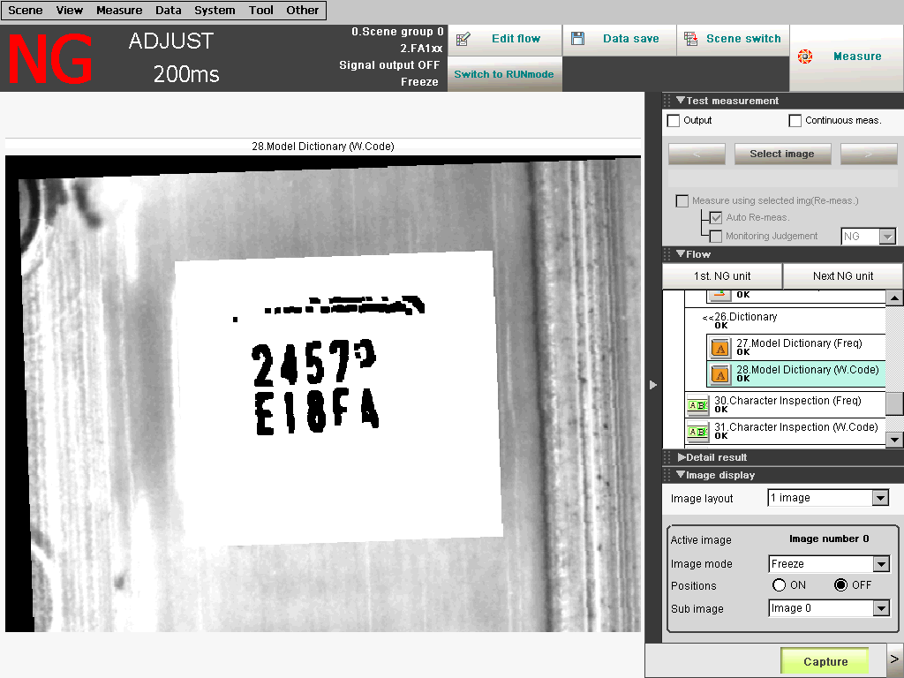

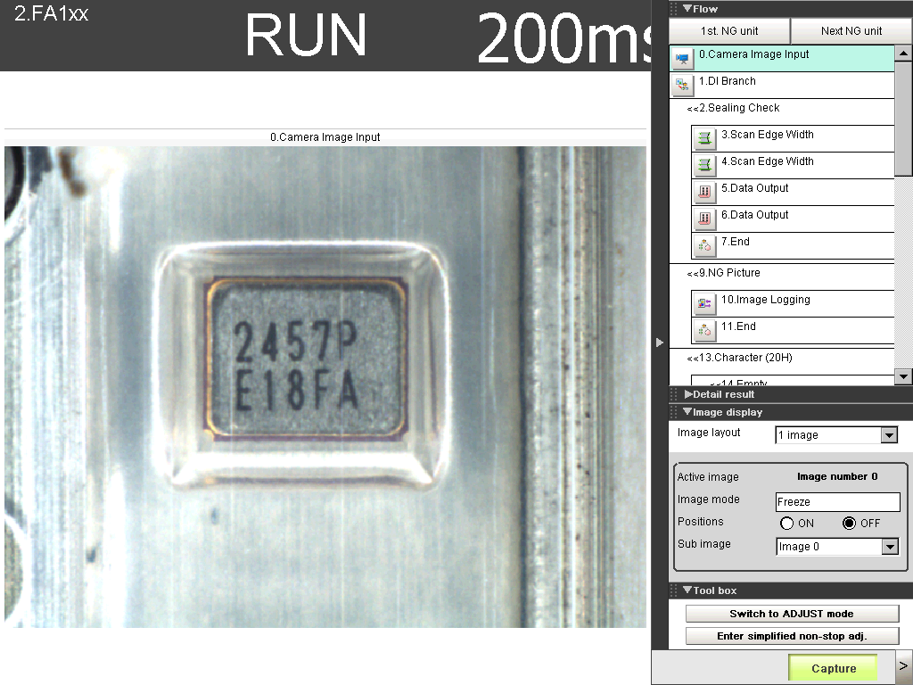

**Conclusion:**

1. There is a significant improvement on the input image after the magnet bar is installed.
2. To increase the accuracy of character recognition, the surrounding ‘Black Dot’ is make disappear in order to prevent the information of an input image is distorted. This is done through the setting of the camera’ gain, filtering as well as BGS level.
3. The vision system will simply return a character by lower the setting value of ‘Correlation’, ‘Rough Candidate’ and ‘Detail Candidate’.
4. Adjust the setting as mentioned in (3) could have significant effect in Measurement time.
5. To overcome the measurement time issue, it can be considered in order to narrow down the Region of Interest in Character Inspection routine.
6. The idea measurement time would within 180 milliseconds which probably will takes less than 30 minutes to complete 1 Lot (3000pcs).
7. 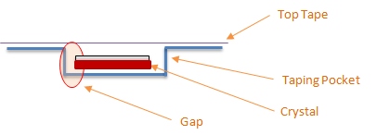The reason of install a magnet bar is as shown in figure below.

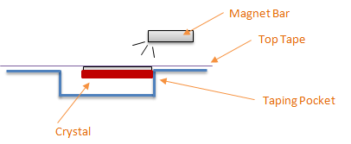

The crystal is attracted to a same location.

1. Regardless of the thickness of the crystal which varies from 1 code to another, the camera would have a same focus among all others code.

Camera

Distance of Focus



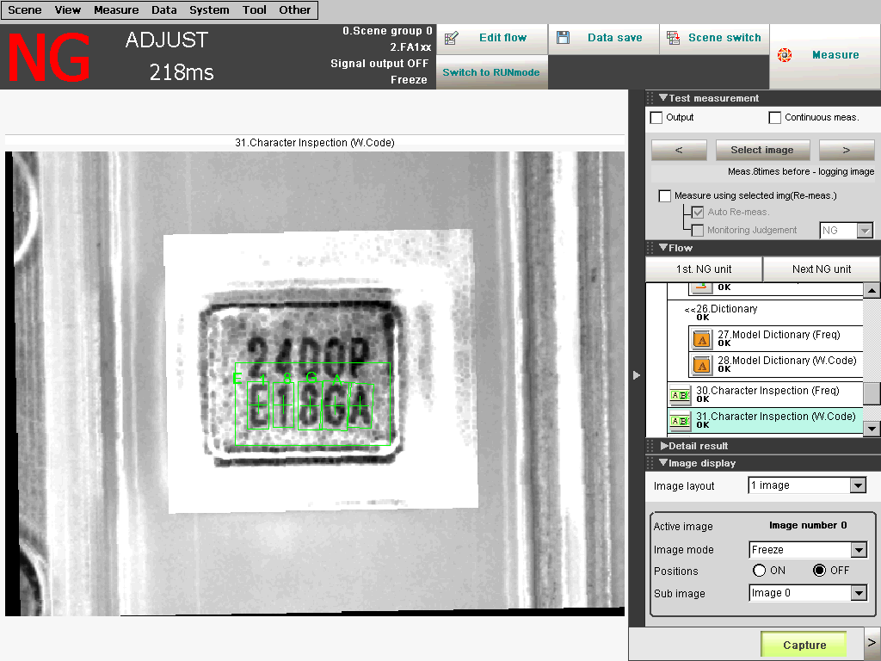

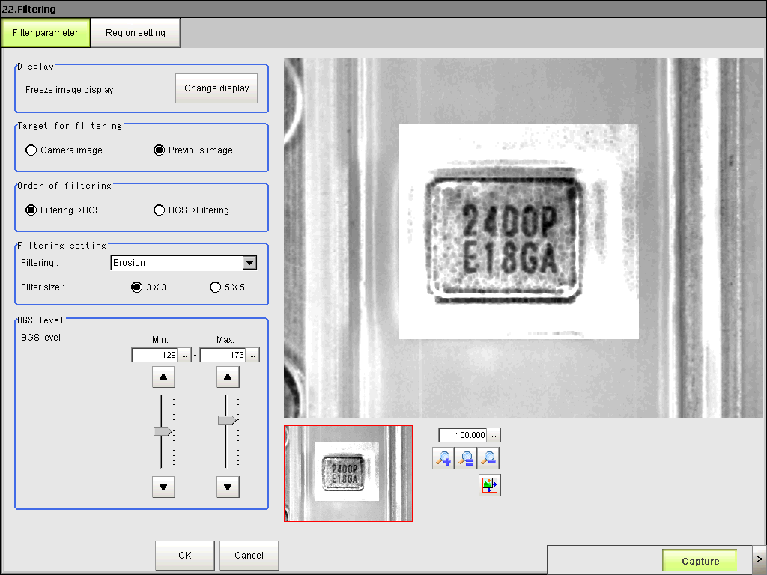

With a further analysis done on the normal Top-Tape, we found that by carefully define the setting of Camera’s gain and filtering, we manage to obtain an image as shown in the screen shot. With these screen shot, Taping OAI now can operate with normal Top-Tape. Of cause, clear and transparent Top-Tape is preferable but if the Top-Tape always having tiny line will significantly affect to the production output.

In addition, we have tested normal Top-Tape (FA-128P) on machine No.5 which has the magnet bar installed. The result seem to be positive and within satisfaction level. There are still a lot of things still can be fine tune. Due to the finding, I hereby declare that the Taping OAI machine has been enhanced to make the impossible to a possible circumstance. We are now competent with Nakamura’s Taping OAI with single lighting, less expensive as well as wider flexibility.